Current Arrays Plots from Dyno Data

Zainab Hussein

3-22-2017

# Background

For function taking inputs of throttle, load and voltage, outputting torque, rpm and torque as shown in equation 1, the mathematical model used to analyze the three output parameters is conservation of power of our motor and motor controller system. The input electrical power and output mechanical power are defined in equation 2 and 3.

$f\left(throttle,load,voltage\right)=\left[torque rpm current\right]$ Eq.1

$P_{IN}=VI$ Eq.2

$P_{OUT}= τω$ Eq.3

Where V is supply voltage, I is supply current, 𝜔 is motor speed in rpm, 𝜏 is load torque.

# Hypothesis

The goal is conservation of power, for a lossless system, input power equals output power. For our motor, we expect a heat loss due to the lossy nature. Electrical power conservation suggests current is directly proportional to input power because voltage is constant, with the voltage as the coefficient of current. However, an analysis of torque or rpm coefficient is not possible when both parameters are changing. Thus, rpm is held constant to examine torque relation to current and vice versa for rpm.

# Method and Result

Figure 1 is a 3D mesh plot with current as the z-axis, slices at different z positions should show a hyperbolic relation of torque and rpm to conserve output power. The blue conglomerations in figure represent the original data collected plotted against the green wire frame plotted from a matrix converted from the original data.

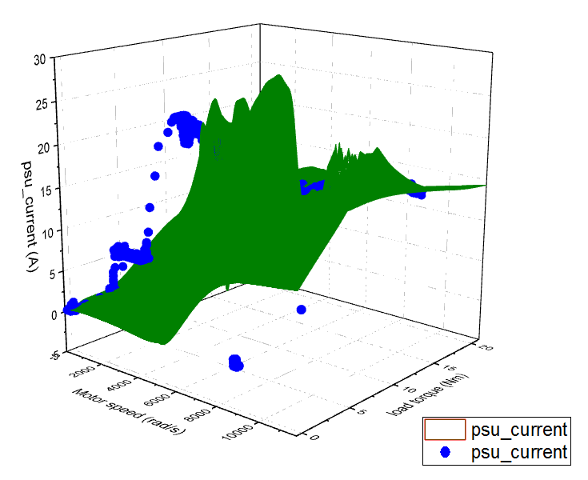

Figure 1 Wire frame 3D surface plot of current, rpm and torque

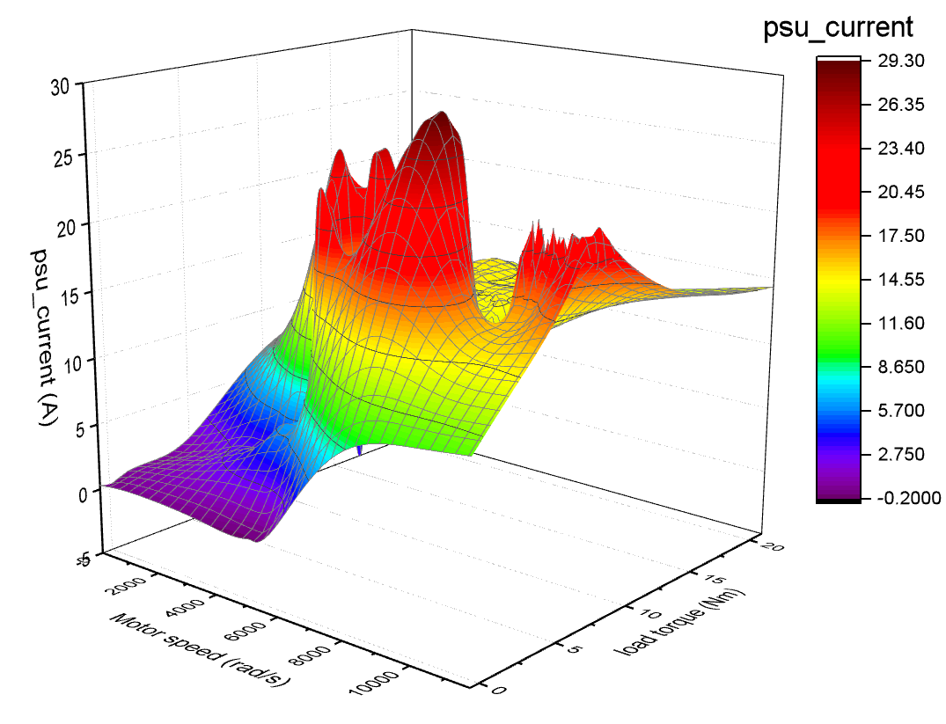

Figure 2 Colormap of current, rpm and torque

## Current Arrays

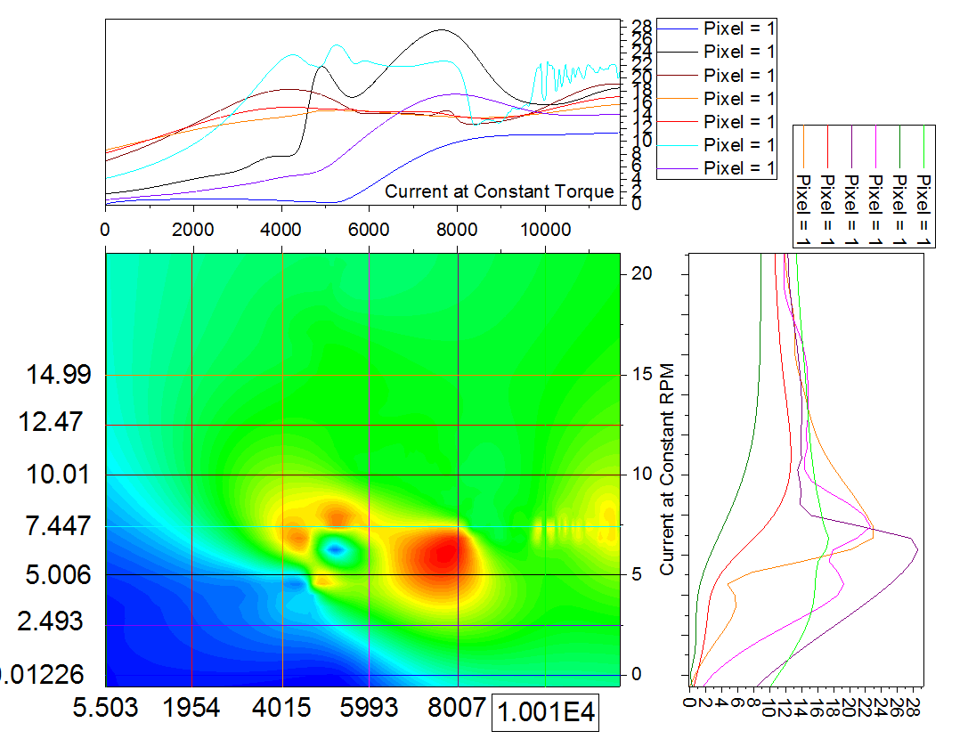

## Table 1

|  |  |  |
| --- | --- | --- |
| Current at Constant Torque values * | | |
|  | Actual Torque (Nm) | Approximate torque (Nm) |
| Pixel 1 | 0.012 | 0 |
| Pixel 2 | 5.006 | 5 |
| Pixel 3 | 10.01 | 10 |
| Pixel 4 | 14.99 | 15 |
| Pixel 5 | 12.47 | 12.5 |
| Pixel 6 | 7.447 | 7.5 |
| Pixel 7 | 2.493 | 2.5 |

*Values correspond to the descending order of pixel names on the label to the right of the current at constant torque graph

## Table 2

|  |  |  |
| --- | --- | --- |
| Current at Constant RPM values* | | |
|  | Actual RPM (rad/s) | Approximate RPM (rad/s) |
| Pixel 1 | 10010 | 10000 |
| Pixel 2 | 0 | 0 |
| Pixel 3 | 5993 | 6000 |
| Pixel 4 | 8007 | 8000 |
| Pixel 5 | 1954 | 2000 |
| Pixel 6 | 4015 | 4000 |

*Values correspond to the descending order of pixel names on the label to the right of the current at constant rpm graph

(Discussion of the plots to continue 3-23-2017)

# References:

Plotting 3D surfaces in Origin: <http://wiki.originlab.com/~originla/howto/index.php?title=Tutorial:3D_Plotting>

<http://www.originlab.com/index.aspx?go=Products/Origin/Graphing>